Technical Design Document

Project name: **EasyPay**

**Introduction:**

Easy pay is created to meet the needs of online transaction services. The architecture implemented is Spring Boot services.

**Functional Requirements:**

The functional requirements of the project are:

**For the User:**

* Login/Register new User
* Deposit money
* Withdraw money
* Fund Transfer
* Print transaction
* Show Balance
* Forgot Password
* View Profile

**Services:**

The different services provided by this project are:

* **Login/Register new User:** Insert a new user or update an existing user. Register a new account and login with that account and access all the functionality of wallet application.
* **Deposit money:** Deposit amount into your account by providing account details.
* **Withdraw money:** withdraw amount from your account by providing account details.
* **Fund Transfer:** User can transfer money from his/her account to another registered user by simply selecting the username from the list of users.
* **Print transaction:** Get all transactions list made his/her account.
* **Show Balance:** show the current balance of their wallet account.
* **Forgot password:**  User can update his/her password.
* **View profile:** User can view their profile details.

**Overall Architecture Diagram:**

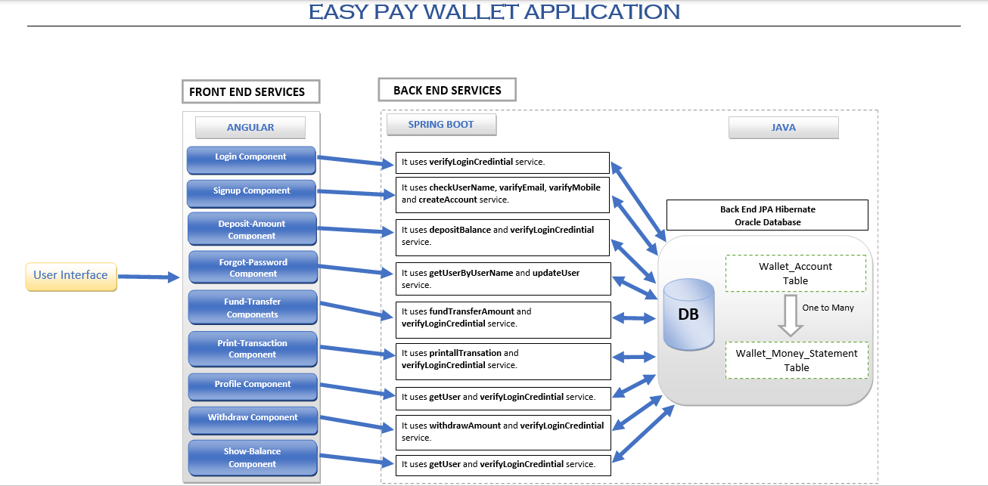

**Overall Entity Relationship Diagram:**

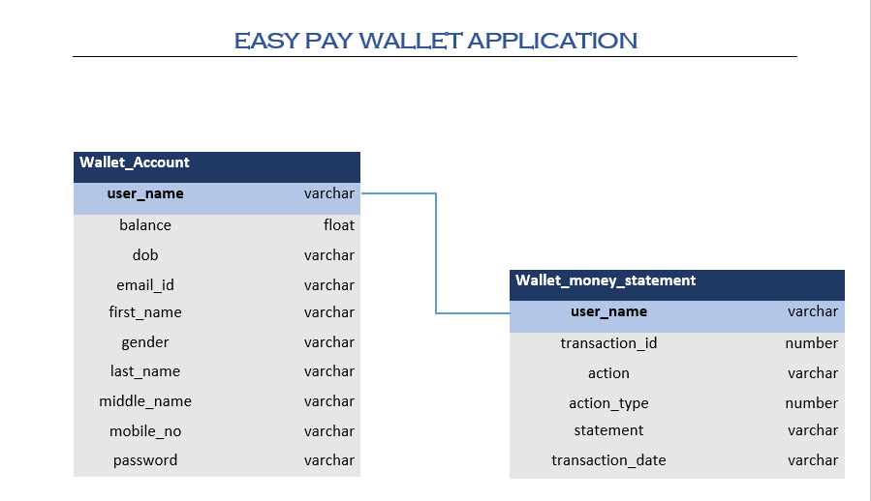

**Class Diagrams**

